PROJECT REPORT

On
Fit Kit for User

From

ANALYZE INFOTECH

Towards partial fulfillment of the requirements
for the award of degree of

Bachelor of Computer Applications

From

Shri Ramswaroop Memorial University
Lucknow

Academic Session 2024 - 25

School of Computer Applications

PROJECT REPORT

On
Fit Kit for User

From

ANALYZE INFOTECH

Towards partial fulfillment of the requirements
for the award of degree of

Bachelor of Computer Applications

From

Shri Ramswaroop Memorial University
Lucknow

Developed and Submitted by Under Guidance of
< Name of the Student> <Name of the Guide>
< University Roll No> <Designation>

Academic Session 2024 - 25

School of Computer Applications

Under taking

This is to certify that Project Report entitled

Fit Kit for User
being submitted by

<Name of the Student>

Towards the partial fulfillment of the requirements
for the award of the degree of

Bachelor of Computer Applications
to
Shri Ramswaroop Memorial University
Lucknow
Academic Year 2024-25

is a record of the student’s own work carried out at

ANALYZE INFOTECH

and to the best of our knowledge the work reported herein does not form a part of any other thesis or work based on which degree or award was conferred on an earlier occasion to this or any other candidate.
Authorized Signatory Students’ Signature
Organization Name Name:
Roll No:

CERTIFICATE

DECLARATION

I, hereby declare that the report entitled “Fit Kit for User” submitted to the School of Computer Applications, Shri Ramswaroop Memorial University, SSRM Tindora, Uttar Pradesh, 225003, is submitted in partial fulfilment of the requirements for the award of the degree of Bachelor of Computer Applications in specialization with Data Science & Artificial Intelligence.
This report is the outcome of my own effort and has been completed under the guidance and supervision of K.K PANDEY SIR. I also declare that the contents of this report have not been submitted, either in full or in part, to any other university or institution for the award of any degree or diploma.

Place: Lucknow
Date: 17/06/2025

Signature of the Student
Students’ Name:
University Roll No.:

Acknowledgment

It gives us immense pleasure to express our sincere gratitude to all those who extended their support and guidance throughout the course of this project. The successful completion of this work would not have been possible without the encouragement and assistance of many individuals.
First and foremost, we would like to extend our profound gratitude to Dr. Reena Srivastava, Honourable Dean, School of Computer Applications, Shri Ramswaroop Memorial University, for her continued support, motivation, and encouragement. Her visionary leadership and guidance have always been a source of inspiration for us. We are also deeply thankful to Dr. Prabhas Chandra Pathak, Head of the Department, School of Computer Applications, for his constant support and valuable insights, which played a vital role in shaping our project and helping us stay focused on our objectives.
We extend our deep appreciation to our project guide, K.K Pandey Sir, for his unwavering support, expert guidance, and timely feedback throughout the duration of the project. His willingness to assist us at every step and address our queries with patience greatly contributed to the successful completion of this work. We would also like to express our gratitude to the Training and Placement Coordinators for their support, cooperation, and guidance during this project.
Last but not the least, we sincerely thank our families and friends for their constant support, understanding, and motivation. Their encouragement has been a strong pillar behind our consistent efforts.

Index
S.No. | Title | Page no.
I | Certificate | IV
II | Declaration | V
III | Acknowledgement | VI
IV | Index | VII-VIII
1 | Introduction | 1
2 | Problem Definition | 2
2.1 | Purpose | 2
2.2 | Scope | 2
3 | Objective | 3
3.1 | Functional requirements | 3
3.2 | Non-Functional requirements | 3-4
4 | Requirement Specifications | 5
4.1 | Hardware requirements | 5
4.2 | Software requirements | 5
5 | Module Description | 6-7
6 | Problem Formulation | 7
7 | Feasibility Study | 8-9
8 | Problem Specifications | 10-15
9 | System Architecture Design | 16-17
10 | System Analysis | 18
11 | E-R Diagram | 19-22
12 | Data Flow Diagram | 23-26
13 | Project Planning & Scheduling | 27-28
14 | Coding | 29-50
15 | Screenshot | 51
16 | Testing | 52-59
17 | Conclusion | 60
18 | Future Scope | 61
19 | Bibliography | 62

INTRODUCTION
Fit Kit is a user-friendly fitness and wellness application designed to help individuals take control of their health, workouts, diet, and lifestyle goals through a personalized and interactive platform. It serves as a digital fitness assistant that enables users to plan, track, and improve their physical well-being anytime, anywhere.
Whether the goal is to lose weight, build muscle, eat healthier, or simply stay active, Fit Kit offers the tools and support needed to stay consistent and motivated. With a combination of smart tracking, customized routines, expert guidance, and progress monitoring, Fit Kit becomes an all-in-one solution for personal health management.
Core Features for Users
- Customized workout plans
- Diet and nutrition tracking
- Weight and progress monitoring
- Yoga, meditation, and wellness sessions
- Daily reminders and motivational tips
- Interactive dashboard for performance insights

PROBLEM DEFINITION
In today’s fast-paced world, many individuals struggle to maintain a consistent and healthy lifestyle due to various challenges such as lack of time, knowledge, motivation, or access to professional fitness guidance. As a result, users often experience:
Key Problems Faced by Users:
- Lack of Personalized Fitness Guidance
Most people do not have access to fitness coaches or customized workout and diet plans.
- Inconsistent Tracking of Health Goals
Users find it difficult to monitor their daily progress in terms of workouts, diet, weight, sleep, and overall well-being.
- Low Motivation and Engagement
Without timely reminders, motivation tips, and visual progress, users tend to lose interest or skip routines.
- Scattered Fitness Information
Many users rely on multiple sources for workout videos, meal planning, and tracking, resulting in confusion and inefficiency.
Purpose:
The primary purpose of Fit Kit is to empower users to take charge of their physical and mental well-being by providing a comprehensive digital fitness platform that integrates:
- Customized workout routines
- Personalized diet plans
- Real-time progress tracking
- Motivational and wellness content
It aims to solve common health and fitness challenges by:
- Guiding users through professionally designed fitness programs tailored to their individual goals (such as weight loss, muscle building, or general health).
- Offering a convenient and accessible platform that allows users to manage workouts, nutrition, and health data—anytime, anywhere.
- Encouraging consistency through reminders, motivational tips, and daily task tracking.
- Visualizing progress to help users stay motivated and adjust their plans as needed.
- Educating users with fitness knowledge, proper workout techniques, and wellness practices.
Scope:
Fit Kit is designed for a wide range of users including:
- Beginners who want to start their fitness journey.
- Busy professionals looking for flexible workout options.
- Fitness enthusiasts tracking their progress.
- Individuals managing weight or specific health goals.
The platform supports:
- Personalized workout and meal plans
- Step, sleep, water, and weight tracking
- Video tutorials and wellness guides
- Reminders, goal setting, and motivational tips
It is accessible through both mobile and web platforms, making fitness available anytime, anywhere.

.
OBJECTIVE
Provide Personalized Fitness Plans
To offer users customized workout and diet plans based on their individual fitness goals, body type, and lifestyle (e.g., fat loss, muscle gain, general wellness).
Enable Real-Time Health and Activity Tracking
To allow users to track steps, calories burned, water intake, sleep duration, heart rate, and body weight in one unified dashboard.
Improve User Engagement and Consistency
To help users stay consistent by sending daily reminders, motivational quotes, and achievement badges for completed goals.
Offer Educational Resources and Video Guides
To guide users through proper workout techniques, recovery tips, and nutrition advice using video tutorials and articles.
Create a Centralized Fitness Log
To give users a single platform where they can record their progress, view historical data, and analyze trends in their fitness journey.
Support Mental Wellness
To include yoga, meditation, and breathing exercises for holistic health and stress management.
Ensure a User-Friendly and Accessible Experience
To design an intuitive, mobile-friendly interface that makes fitness tools and information easily available to users of all backgrounds.
Provide Goal Setting and Progress Monitoring
To let users set daily, weekly, or monthly fitness goals and visualize their progress using graphs and stats.

Functional Requirements:
These are the essential features and functionalities that the Fit Kit platform must provide for users:
1. User Registration and Login
- Users can sign up/login via email or social accounts (Google, Apple).
- Secure authentication with options to reset password or enable biometric login.
2. Workout and Fitness Plan Management
- Access to custom workout plans based on user goals (weight loss, muscle gain, etc.).
- Ability to start, pause, skip, or reschedule workout sessions.
- Daily checklist of assigned workouts and rest days.
3. Diet and Nutrition Tracking
- Personalized meal plans and food suggestions based on calorie needs.
- Users can log their meals manually or via barcode scanning.
- Daily nutrition summary (calories, protein, carbs, fats).
4. Health & Progress Tracking
- Log and view steps, calories burned, weight, sleep hours, water intake, etc.
- Visual charts and graphs show weekly/monthly progress.
- Sync with fitness devices (optional future integration).
5. Reminders and Notifications
- Push notifications/reminders for:
  - Workout time
  - Meal tracking
  - Water intake
  - Meditation or sleep schedule

6. Video Tutorials and Education
- Access a library of exercise videos and wellness content.
- Categorized by body part, difficulty level, and equipment type.
7. Goal Setting and Achievement
- Set fitness goals (e.g., lose 5kg in 2 months).
- View progress bar and earn badges/achievements upon milestones.
8. Profile and Settings
- Edit personal details (age, weight, height, goal).
- Change fitness plans, notification preferences, or app themes.
9. History and Reports
- Access history of past workouts, meals, and logs.
- Exportable reports in PDF/CSV format for medical or personal use.
Non-Functional Requirements:
These requirements define how the Fit Kit system should perform, focusing on user experience, performance, and security rather than specific features.
1. Performance
- The system should respond to user actions (logging data, viewing progress, loading videos) within 2 seconds.
- Must support simultaneous access by thousands of users without lag.
2. Usability
- The interface must be clean, intuitive, and beginner-friendly.
- Support for touch gestures on mobile and voice commands (optional future upgrade).
- Accessibility support (for visually impaired or colour-blind users).

3. Reliability
- The system should provide 99.5% uptime, with backup recovery in case of crashes.
- Autosave functionality to prevent loss of user inputs (e.g., workout logs).
4. Maintainability
- Codebase should follow modular architecture for easier bug fixing, updates, and feature additions.
- Proper documentation and logging for system administrators.
5. Compatibility
- The application must work smoothly on:
  - Android and iOS devices
  - Multiple screen sizes (phones, tablets)
  - Modern web browsers
6. Scalability
- Fit Kit should be designed to handle growth—more users, more data, and future modules like wearable device syncing or live trainer sessions.

REQUIREMENTS SEPECIFICATIONS

HARDWARE SPECIFICATION

Component | Minimum Requirement | Recommended Requirement
Processor | Quad-Core (e.g., Intel Xeon / Ryzen) | 8-Core Server Grade CPU
RAM | 8 GB | 16–32 GB
Storage |  | 512 GB SSD or NVMe
  256 GB SSD
Network | 10 Mbps or above | 100 Mbps or above

SOFTWARE SPECIFICATION

Software | Description
OS
  Windows 10+, Linux, or macOS
Browser | Google Chrome, Firefox, Safari
Framework | React.js
Libraries | Axios, React Router, Tailwind CSS, Mongoose, Cors, Multer, ExpressJs
Run Time Environment | NodeJS
Database | MongoDB Community Server

PROBLEM FORMULATION
"Design and develop a digital fitness platform that helps users manage their health and fitness goals by offering personalized workout and diet plans, real-time progress tracking, educational resources, and motivational tools—accessible anytime, anywhere."
Issues Identified in the Problem Formulation:
- Fragmented Fitness Journey
Users often rely on multiple apps for workouts, diet tracking, and health logs—causing data fragmentation and lack of clarity.
- Low Motivation and Retention
Without regular reminders, visible progress, or achievements, users tend to drop out of fitness programs early.
- Lack of Personalization
Generic plans don’t suit everyone; users need tailored routines based on their body type, lifestyle, and goals.
- Poor Health Awareness
Many users lack guidance on proper workout techniques, nutrition, recovery, and mental wellness.
- Inaccessibility of Expert Help
Hiring personal trainers or nutritionists is often expensive and time restrictive.
FEASIBILITY STUDY
A feasibility study helps determine whether the Fit Kit system is practical and viable to build and operate, analysing it from multiple angles: technical, economic, operational, legal, and schedule feasibility.
Technical Feasibility
- Technology Availability: Easily developed using modern frameworks:
  - Frontend: Flutter / React Native (for mobile apps)
  - Backend: Node.js, Django, or Firebase
  - Database: MongoDB / PostgreSQL
  - APIs: Google Fit, Apple HealthKit, wearable device integrations
- Feasibility: Highly feasible using existing technologies.
- Challenges: Real-time syncing and ensuring data accuracy from third-party fitness trackers.
Economic Feasibility
- Development Cost: Moderate, scalable depending on platform features and scope.
- Revenue Models:
  - Freemium model (basic features free, premium features paid)
  - Subscription plans
  - Brand collaborations for fitness products/services
- ROI Potential: High, due to the booming fitness app market.
Operational Feasibility
- User Adoption: High demand due to growing health awareness and smartphone usage.
- Maintenance: Requires routine updates, customer support, and new content (workout videos, nutrition info).
Legal Feasibility
- Data Privacy: Must comply with laws like GDPR or India’s IT Act 2000 to protect user health data.
- Medical Disclaimer: Must include disclaimers stating the app is for guidance only and not a substitute for professional advice.
Schedule Feasibility
- Time Estimation:
  - MVP: 2–3 months
  - Full-feature version: 6–8 months
- Phased Delivery: Can be launched in stages—basic features first, then advanced analytics, video content, and integrations.
- Feasibility: Achievable within a reasonable timeline.

PROBLEM SPECIFICATION
The Problem Specification outlines the detailed expectations, input-output behavior, and system boundaries for the Fit Kit platform.
1. Functional Specifications
- User Authentication
  - Users can sign up, log in, and reset passwords securely.
- Personalized Fitness and Diet Plans
  - Users receive tailored workout and nutrition plans based on inputs like age, weight, gender, fitness goals, and activity level.
- Workout Management
  - Access and log exercises daily.
  - Track progress, complete sets/reps, and view instructional videos.
- Nutrition Tracking
  - Add daily meals manually or through a food database.
  - View nutrient breakdown and calories consumed.
- Health Metrics Logging
  - Track water intake, body weight, sleep, steps, and other key stats.
  - View daily, weekly, and monthly graphs.
- Reminders and Notifications
  - Automated push notifications for workouts, meals, water, and rest.

- Progress Reports
  - Graphs showing progress toward fitness goals.
  - Exportable data summaries for personal review or sharing.
- Educational Content
  - Articles, fitness tips, and wellness videos to educate users on health topics.
2. Non-Functional Specifications
- Security: All user data must be encrypted; app must comply with data protection laws.
- Responsiveness: App must be fully responsive on all screen sizes.
- Performance: All key actions (e.g., log activity, load video) must complete within 2 seconds.
- Availability: The system must ensure 99.5% uptime.
- Scalability: Support increasing number of users and data entries without performance loss.
3. System Constraints
- Internet connectivity required for syncing data and loading content.
- Device sensors (accelerometer, GPS, etc.) required for some tracking features.
- Accurate results depend on user input and third-party integrations (e.g., fitness wearables).

COMPONENT DIAGRAM
The component diagram contains components and dependencies. Components represent the physical packaging of a module of code. The dependencies between the components show how changes made to one component may affect the other components in the system. Dependence in a component diagram are represented by a dashed line between two or more components. Component diagrams can also show the interfaces used by the components to communicate to each other.

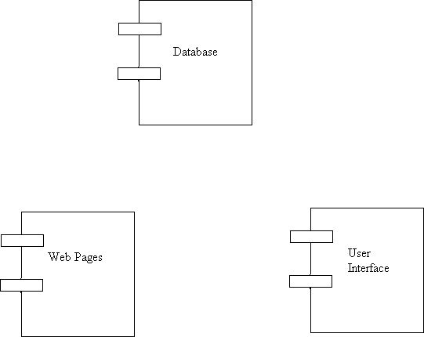

Figure of Component Diagram

Deployment Diagram:
Deployment and component diagram combines the features of both diagrams into one diagram.
The deployment diagram contains nodes and connections. A node usually represents a piece of hardware in the system. A connection depicts the communication path used by the hardware to communicate and usually indicates a method such as TCP/IP.

DB
UI
Web Server

Web pages

Figure of Deployment Diagram

SYSTEM ARCHETECTURE DESIGN
Defining System:
Collection of components, which are interconnected, and work together to realize some objective, from a system. There are three components in every system, namely input, processing and output

Input Output
Processing

System Development of Life Cycle:
The System development life cycle (SDLC), or Software development process in systems engineering, information systems and software engineering, is a process of creating or altering information systems, and the models and methodologies that people use to develop these systems. In software engineering, the SDLC concept underpins many kinds of software methodologies. Broadly, following are the different activities to be considered while defining the system development life cycle for the said project:
- Problem
- Definition
- System Analysis
- Study of existing system
- Drawback of the existing system
- Proposed system
- System Requirement study
- Data flow analysis
- Feasibility study
- System design
- Input Design (Database & Forms) Updating
- Query /Report
- Design
- Administration
- Testing
- Implementation
- Maintenance
SYSTEM ANALYSIS
Systems analysis is the study of sets of interacting entities, including computer systems analysis. This field is closely related to requirements analysis or operations research. It is also "an explicit formal inquiry carried out to help someone (referred to as the decision maker) identify a better course of action and make a better decision than he might otherwise have made.
System development can generally be thought of having two major components: systems analysis and systems design. In System Analysis more emphasis is given to understanding the details of an existing system or a proposed one and then deciding whether the proposed system is desirable or not and whether the existing system needs improvement.
Systems design is the process of defining the architecture, components, modules, interfaces, and data for a system to satisfy specified requirements. If the broader topic of product development "blends the perspective of marketing, design, and manufacturing into a single approach to product development," then design is the act of taking the marketing information and creating the design of the product to be manufactured. Systems design is therefore the process of defining and developing systems to satisfy specified requirements of the user. Until the 1990s systems design had a crucial and respected role in the data processing industry. In the 1990s standardization of hardware and software resulted in the ability to build modular systems. The increasing importance of software running on generic platforms has enhanced the discipline of software
ENTITY RELATION DIAGRAMS
The Entity Relation Model or Entity Relation Diagram (ERD) is a data model or diagram for high-level description of conceptual data model, and it provides a graphical notation for representing such data models in the form of entity relationship diagrams. Such models are typically used in the first stage of Management information management system design; they are used for example, to describe information needs and/ or the type of information that is to be stored in the Database during the requirement analysis. The data modeling technique, however, can be used to describe any ontology (i.e. an overview and classification of used terms and their relationships) for a certain universe of discourse (i.e. area of interest).
ER DIAGRAMS:
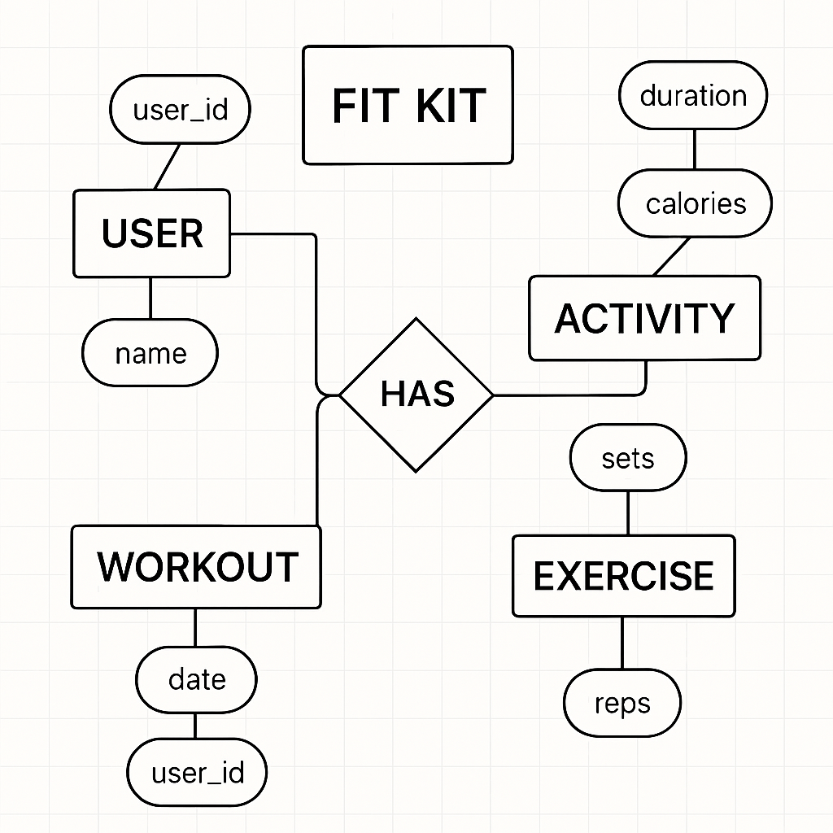
Activity Diagram:
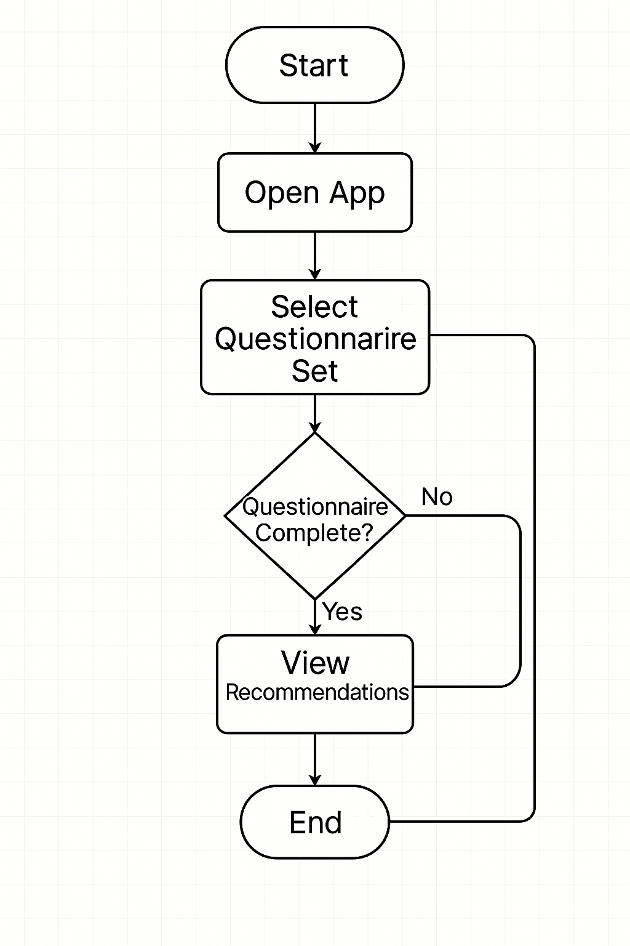

Event Diagram:
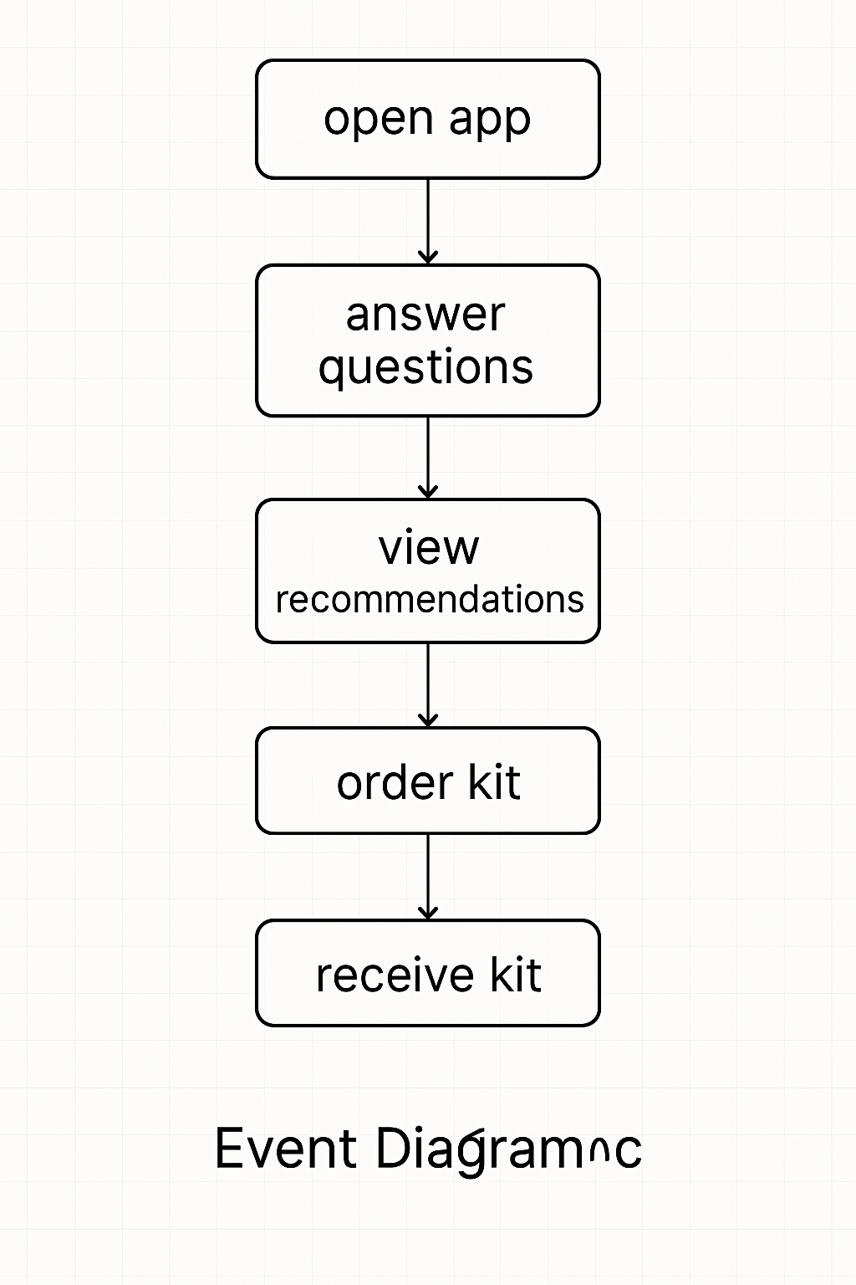

DATA FLOW DIAGRAM
The data flow diagram shows the flow of data within any system. It is an important tool for designing phase of software engineering. Larry Constantine first developed it. It represents graphical view of flow of data. It’s also known as BUBBLE CHART. The purpose of DFD is major transformation that will become in system design symbols used in DFD.
In the DFD, four symbols are used and they are as follows.
- A square defines a source (originator) or destination of system data.

- An arrow identifies data flow-data in motion. It is 2a pipeline through which information flows.

- An open rectangle is a data store-data at rest, or a temporary Repository of data.

- A circle or a “bubble “(Some people use an oval bubble) represents a process that transfers informing data flows into outgoing data flows.

Context Level Data Flow Diagram:
This level shows the overall context of the system and its operating environment and shows the whole system as just one process. Online book store is shown as one process in the context diagram; which is also known as zero level DFD, shown below. The context diagram plays important role in understanding the system and determining the boundaries. The main process can be broken into sub-processes and system can be studied with more detail; this is where 1st level

DFD comes into play.

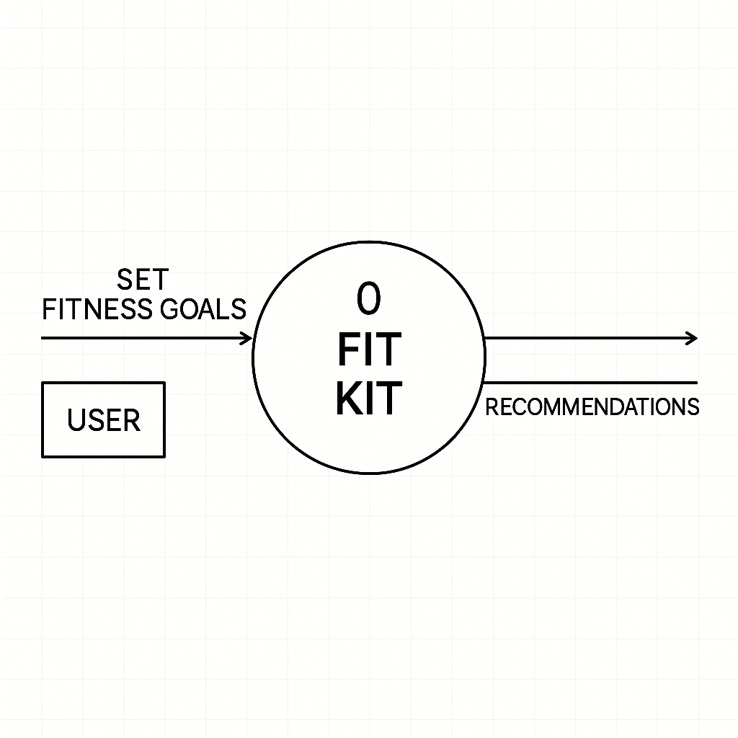

Zero Level Data Flow Diagram
First Level DFD:
This level (level 1) shows all processes at the first level of numbering, data stores, external entities and the data flows between them. The purpose of this level is to show the major high- level processes of the system and their interrelation. A process model will have one, and only one, level 1 diagram. A level 1 diagram must be balanced with its parent context level diagram,
i.e. there must be the same external entities and the same data flows, these can be broken down to more detail at level 1.
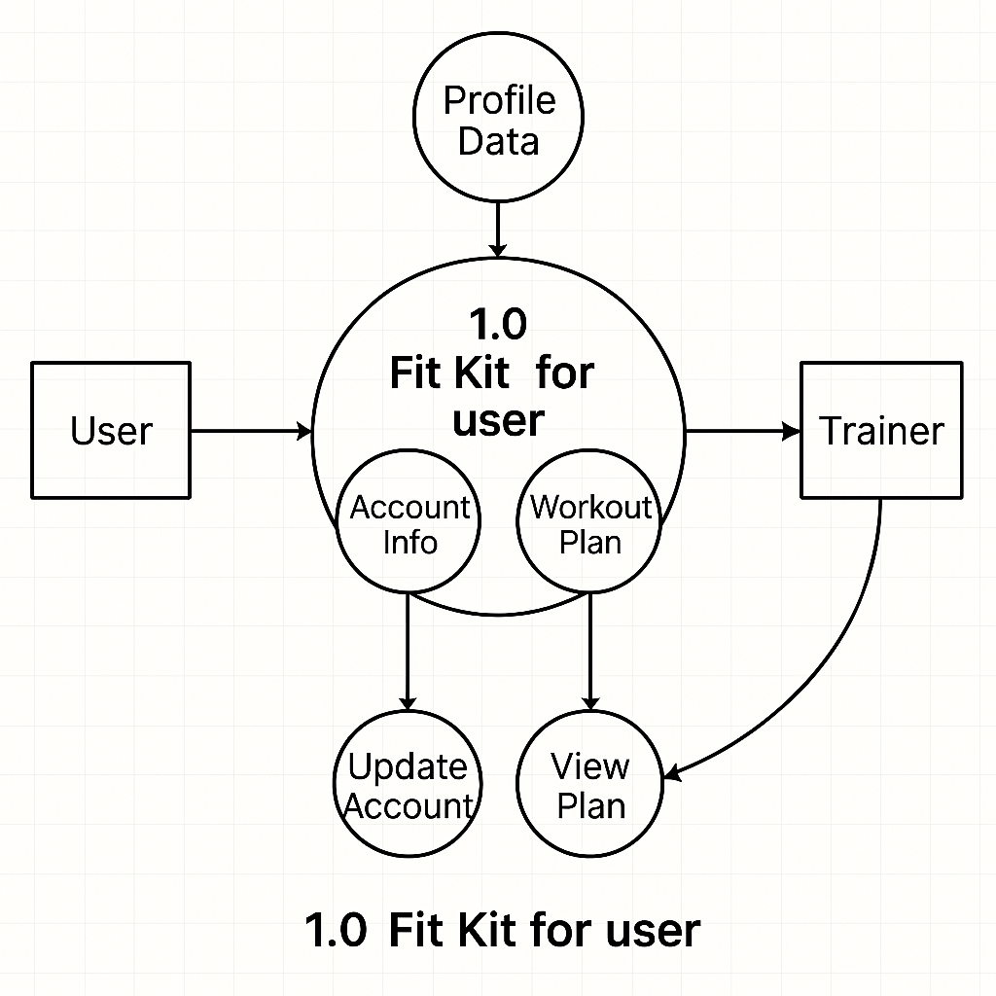

First Level Data Flow Diagram

Class Diagram
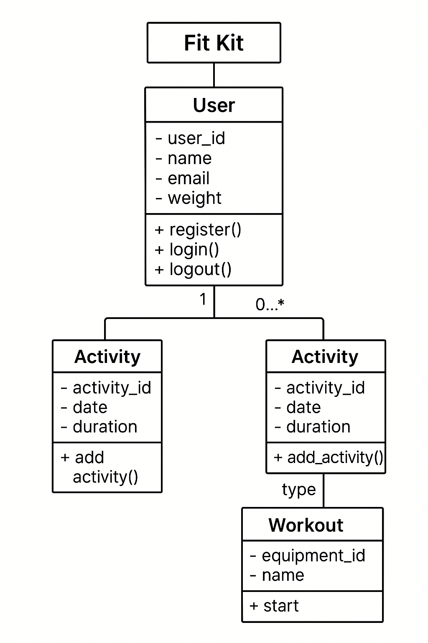
PROJECT PLANNING & SCHEDULING

Pert Chart:
A project plan needs to be created to ensure the timely completion of the project. As part of project analysis, we break the project down to a number of stages and use a Gantt chart and PERT chart to describe specific tasks and status.
The Work Breakdown Structure of our proposed system “E-Commerce” is shown below:

ID | Task Name | Duration | Start | Finish
1 | Project Initiation | 03 days | Tue  18/02/2025 | Fri  21/02/2025
2 | Draft Project Plan | 02 days | Sat  22/02/2025 | Mon  24/02/2025
3 | Analysis Phase | 09 days | Wed  26/02/2025 | Fri  07/03/2025
4 | Plan User Interviews | 02 days | Sat  08/03/2025 | Mon  10/03/2025
5 | Schedule users Interviews | 04 days | Tue  11/03/2025 | Sat  15/03/2025
6 | Conducting users Interviews | 03 days | Mon  17/03/2025 | Thu  20/03/2025
7 | System Design | 10 days | Fri  21/03/2025 | Mon  31/03/2025
8 | Modules Design | 09 days | Tue  01/04/2025 | Thu  10/04/2025
9 | Data Structure Design | 03 days | Fri  11/04/2025 | Mon  14/04/2025
10 | User Interface Design | 02 days | Tue  15/04/2025 | Thu  17/04/2025
11 | Coding Phase | 07 days | Fri  18/04/2025 | Fri  25/04/2025
12 | Testing Phase | 05 days | Fri  25/04/2025 | Wed  30/04/2025
13 | Integration Testing | 03 days | Wed  30/04/2025 | Fri  02/05/2025
14 | System Level Testing | 03 days | Fri  02/05/2025 | Mon  05/05/2025
15 | Implementation | 02 days | Tue  06/05/2025 | Wed  07/05/2025
16 | Post-Implementation Review | 04 days | Thu  08/05/2025 | Mon  12/05/2025

CODING OF PROJECT

App.jsx

import React from "react";
import { BrowserRouter as Router, Switch, Route } from "react-router-dom";
import AppAppBar from "./components/AppAppBar";
import Dashboard from "./pages/Dashboard";
import Error from "./pages/Error";
import Exercises from "./pages/Exercises";
import Index from "./pages/Home";
import User from "./pages/user";
import withRoot from "./components/withRoot";

function App() {
return (
<>
<Router>
<AppAppBar />
<Switch>
<Route exact path="/" component={Index}></Route>
<Route exact path="/user" component={User}></Route>
<Route exact path="/dashboard" component={Dashboard}></Route>
<Route exact path="/exercise" component={Exercises}></Route>
<Route exact path="*" component={Error}></Route>
</Switch>
</Router>
</>
);
}
export default withRoot(App);

Dashboard.jsx

import React, { useState, useEffect } from "react";
import {
withStyles,
makeStyles,
lighten,
} from "@material-ui/core/styles";
import {
Button,
Link,
Table,
TableBody,
TableCell,
TableContainer,
TableHead,
TableRow,
Paper,
Typography,
Divider,
} from "@material-ui/core";
import axios from "axios";

// Styled Table Cells
const StyledTableCell = withStyles((theme) => ({
head: {
backgroundColor: theme.palette.primary.main,
color: theme.palette.common.white,
fontWeight: 600,
fontSize: 16,
},
body: {
fontSize: 14,
color: "#fff",
},
}))(TableCell);

// Alternate Row Coloring
const StyledTableRow = withStyles((theme) => ({
root: {
"&:nth-of-type(even)": {
backgroundColor: "rgba(255, 255, 255, 0.05)",
},
},
}))(TableRow);

// Custom Styles
const useStyles = makeStyles((theme) => ({
layout: {
minHeight: "100vh",
width: "100%",
padding: theme.spacing(2),
display: "flex",
alignItems: "center",
justifyContent: "center",
backgroundImage:
"url('https://humankinetics.me/wp-content/uploads/2018/03/victor-freitas-546968-unsplash.jpg')",
backgroundSize: "cover",
backgroundPosition: "center",
backgroundRepeat: "no-repeat",
},
paper: {
padding: theme.spacing(4),
borderRadius: theme.spacing(2),
backdropFilter: "blur(14px)",
WebkitBackdropFilter: "blur(14px)",
background: "rgba(255, 255, 255, 0.1)",
border: "1px solid rgba(255, 255, 255, 0.2)",
boxShadow: "0 8px 32px rgba(0,0,0,0.3)",
color: "#fff",
width: "100%",
maxWidth: 1000,
},
tableContainer: {
marginTop: theme.spacing(3),
background: "transparent",
},
title: {
fontWeight: 700,
fontSize: 28,
color: "#fff",
marginBottom: theme.spacing(2),
},
deleteBtn: {
color: "#fff",
backgroundColor: "#e53935",
"&:hover": {
backgroundColor: "#c62828",
},
padding: "4px 12px",
fontSize: 12,
borderRadius: 20,
},
copyright: {
marginTop: theme.spacing(4),
textAlign: "center",
color: "#ddd",
},
}));

function Dashboard() {
const classes = useStyles();
const [exercises, setExercises] = useState([]);

useEffect(() => {
axios
.get("http://localhost:5000/exercises")
.then((response) => setExercises(response.data))
.catch((error) => console.log(error));
}, []);

const deleteExercise = (id) => {
axios.delete("http://localhost:5000/exercises/" + id).then(() => {
setExercises((prev) => prev.filter((item) => item._id !== id));
});
};

return (
<main className={classes.layout}>
<Paper className={classes.paper} elevation={3}>
<Typography variant="h4" className={classes.title}>
Dashboard
</Typography>
<Divider style={{ backgroundColor: "rgba(255,255,255,0.2)" }} />
<TableContainer component={Paper} className={classes.tableContainer} elevation={0}>
<Table>
<TableHead>
<TableRow>
<StyledTableCell>User</StyledTableCell>
<StyledTableCell align="right">Activity</StyledTableCell>
<StyledTableCell align="right">Duration (min)</StyledTableCell>
<StyledTableCell align="right">Date</StyledTableCell>
<StyledTableCell align="right">Actions</StyledTableCell>
</TableRow>
</TableHead>
<TableBody>
{exercises.map((row, idx) => (
<StyledTableRow key={idx}>
<StyledTableCell>{row.username}</StyledTableCell>
<StyledTableCell align="right">{row.description}</StyledTableCell>
<StyledTableCell align="right">{row.duration}</StyledTableCell>
<StyledTableCell align="right">
{row.date.substring(0, 10)}
</StyledTableCell>
<StyledTableCell align="right">
<Button
className={classes.deleteBtn}
onClick={() => deleteExercise(row._id)}
>
Delete
</Button>
</StyledTableCell>
</StyledTableRow>
))}
</TableBody>
</Table>
</TableContainer>
<Typography variant="body2" className={classes.copyright}>
© {new Date().getFullYear()}{" "}
<Link href="/" color="inherit">
Fitkit
</Link>
. All rights reserved.
</Typography>
</Paper>
</main>
);
}

export default Dashboard;

backend/index.js

const express = require("express");
const cors = require("cors");
require("dotenv/config");
const mongoose = require("mongoose");

const app = express();
const port = process.env.PORT || 5000;

app.use(cors());
app.use(express.json());
app.get("/", (req, res) => {
res.send("Hello to Fitness Tracker API");
});
mongoose.connect(
process.env.MONGO_URI,
{ useNewUrlParser: true, useCreateIndex: true, useUnifiedTopology: true },
() => console.log("Database connected")
);

const exercisesRouter = require("./routes/exercises");
const usersRouter = require("./routes/users");

app.use("/exercises", exercisesRouter);
app.use("/users", usersRouter);

app.listen(port, () => {
console.log(`Server is running on port: ${port}`);
});

Models/user.js

const mongoose = require('mongoose');

const Schema = mongoose.Schema;

const userSchema = new Schema({
username: {
type: String,
required: true,
unique: true,
trim: true,
minlength: 3
},
}, {
timestamps: true,
});

const User = mongoose.model('User', userSchema);

module.exports = User;

models/exercise.js

const mongoose = require('mongoose');

const Schema = mongoose.Schema;

const exerciseSchema = new Schema({
username: { type: String, required: true },
description: { type: String, required: true },
duration: { type: Number, required: true },
date: { type: Date, required: true },
}, {
timestamps: true,
});

const Exercise = mongoose.model('Exercise', exerciseSchema);

module.exports = Exercise;

DATABASE TABLES

User

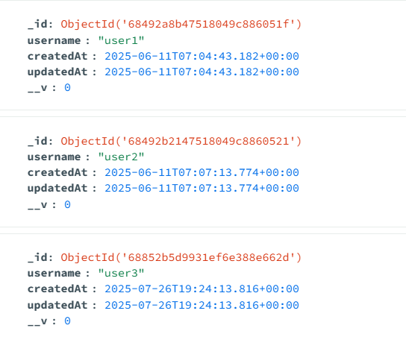

Exercise

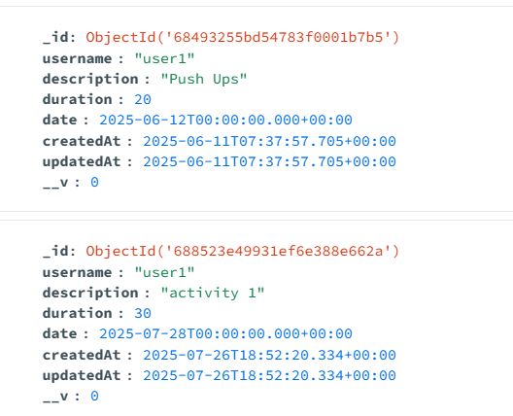

PROJECT SCREENSHOT
Home Page
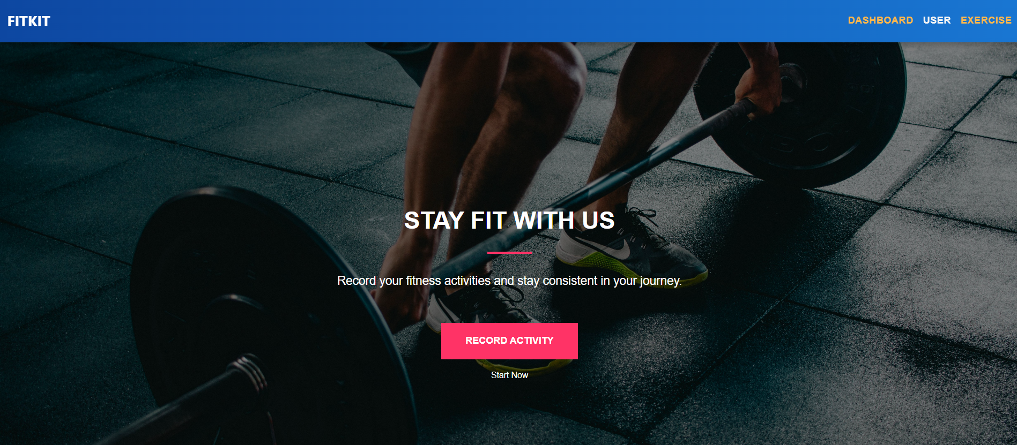
Dashboard
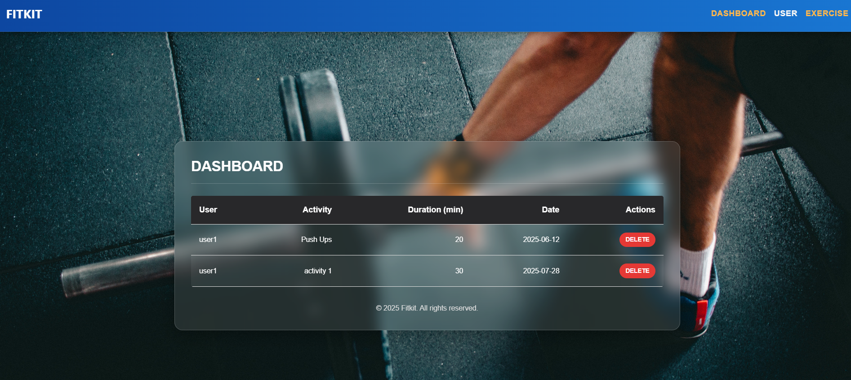

Create User
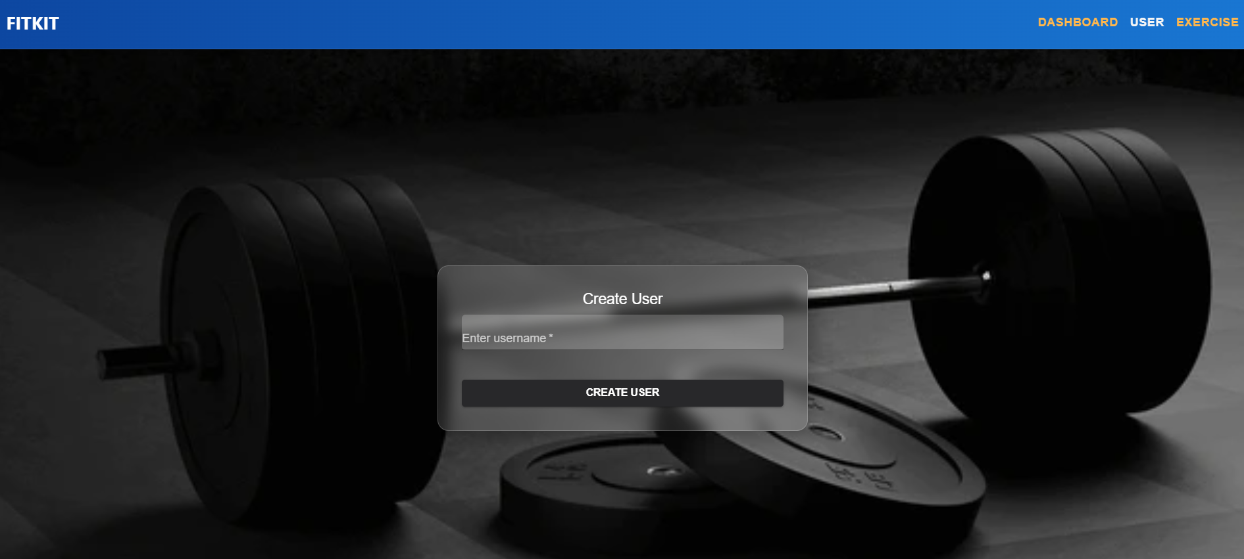
Exerciese
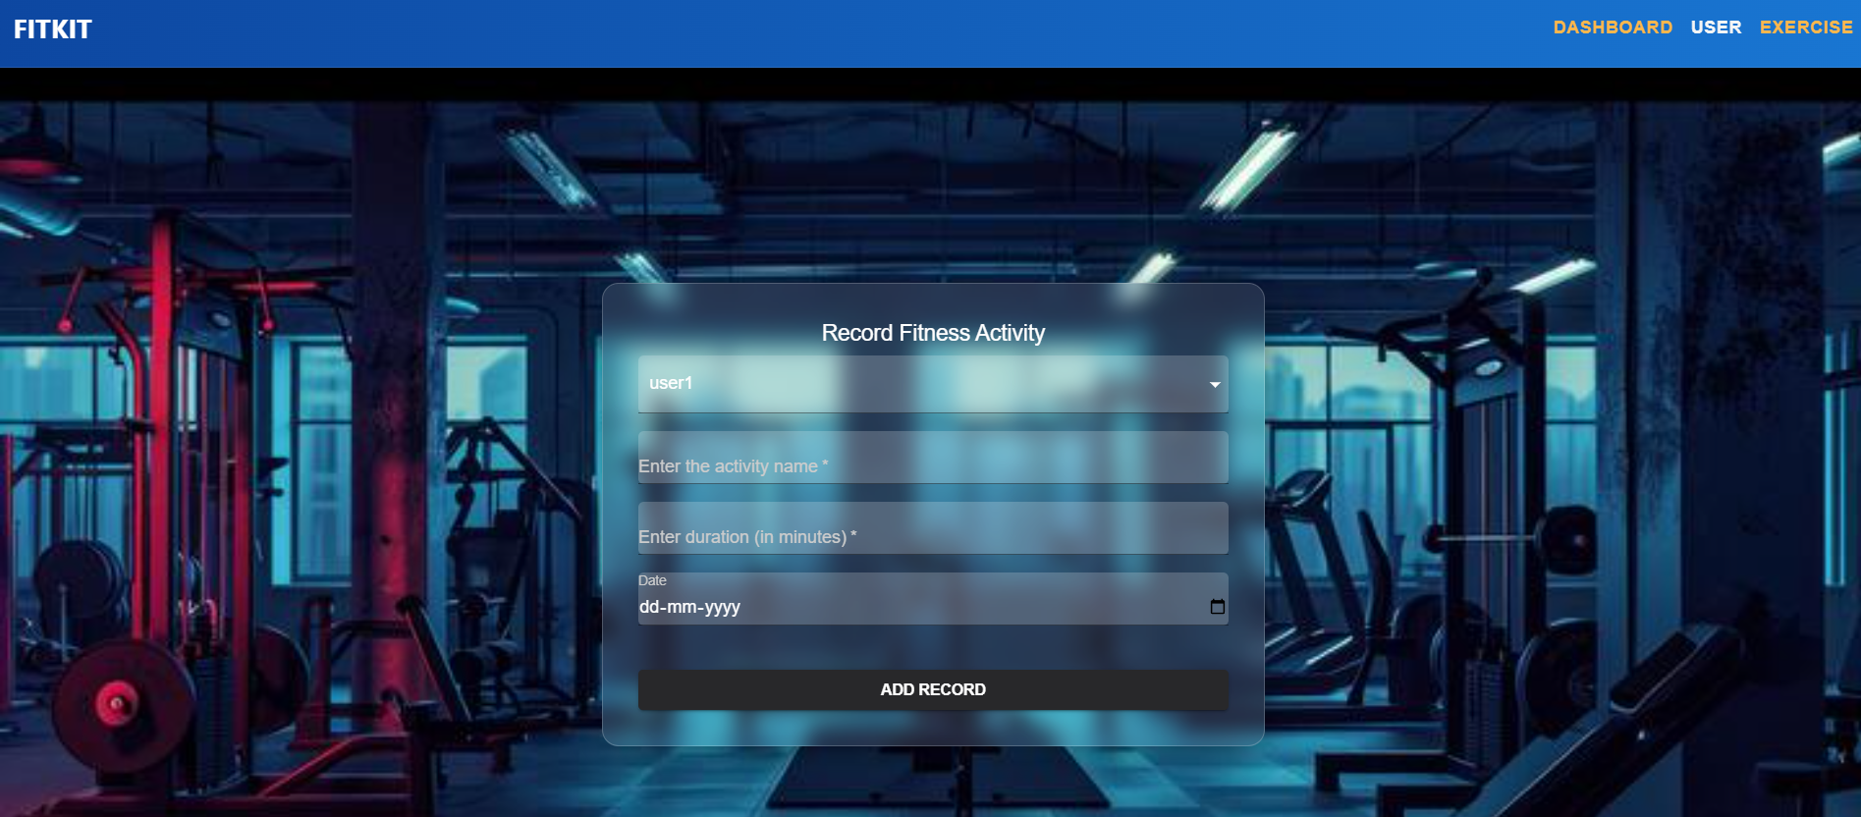

TESTING
- Testing Plan
- Testing Strategy
- Testing Methods
- Test cases and results

Testing:
Generally, it has been specified thought for testing that: “Testing is the critical element of any software quality assurance and represents the ultimate review of specification, design and code generation.” Software testing has a dual function; it is used to establish the presence of defects in program and it is used to help judge whether the program is usable in practice. Thus software testing is used for validation and verification, which ensure that software conforms to its specification and meets the need of the software customer.
Testability
Software Testability is simply how easily a computer program can be tasted. The check list that follows provides a set of characteristics that lead to testable software.
- Operability
- Observables
- Controllability
- Decomposability
- Simplicity
- Stability
- Understandability
The following are the attributes of the Good Test:-
- A good test has a high probability of finding an error.
- A good test is not redundant.
- A good test should be “Best of Breed”.
- A good test would be neither too simple nor too complex.
Interdependency: Interdependencies of each compartmentalized activity were then found out. Some tasks must occur in sequence while there are many tasks which can occur in parallel.

Software Inspection: Analyze and check system representations such as the requirements document, design, diagrams and the program source code. They may be applied at all stages of process.

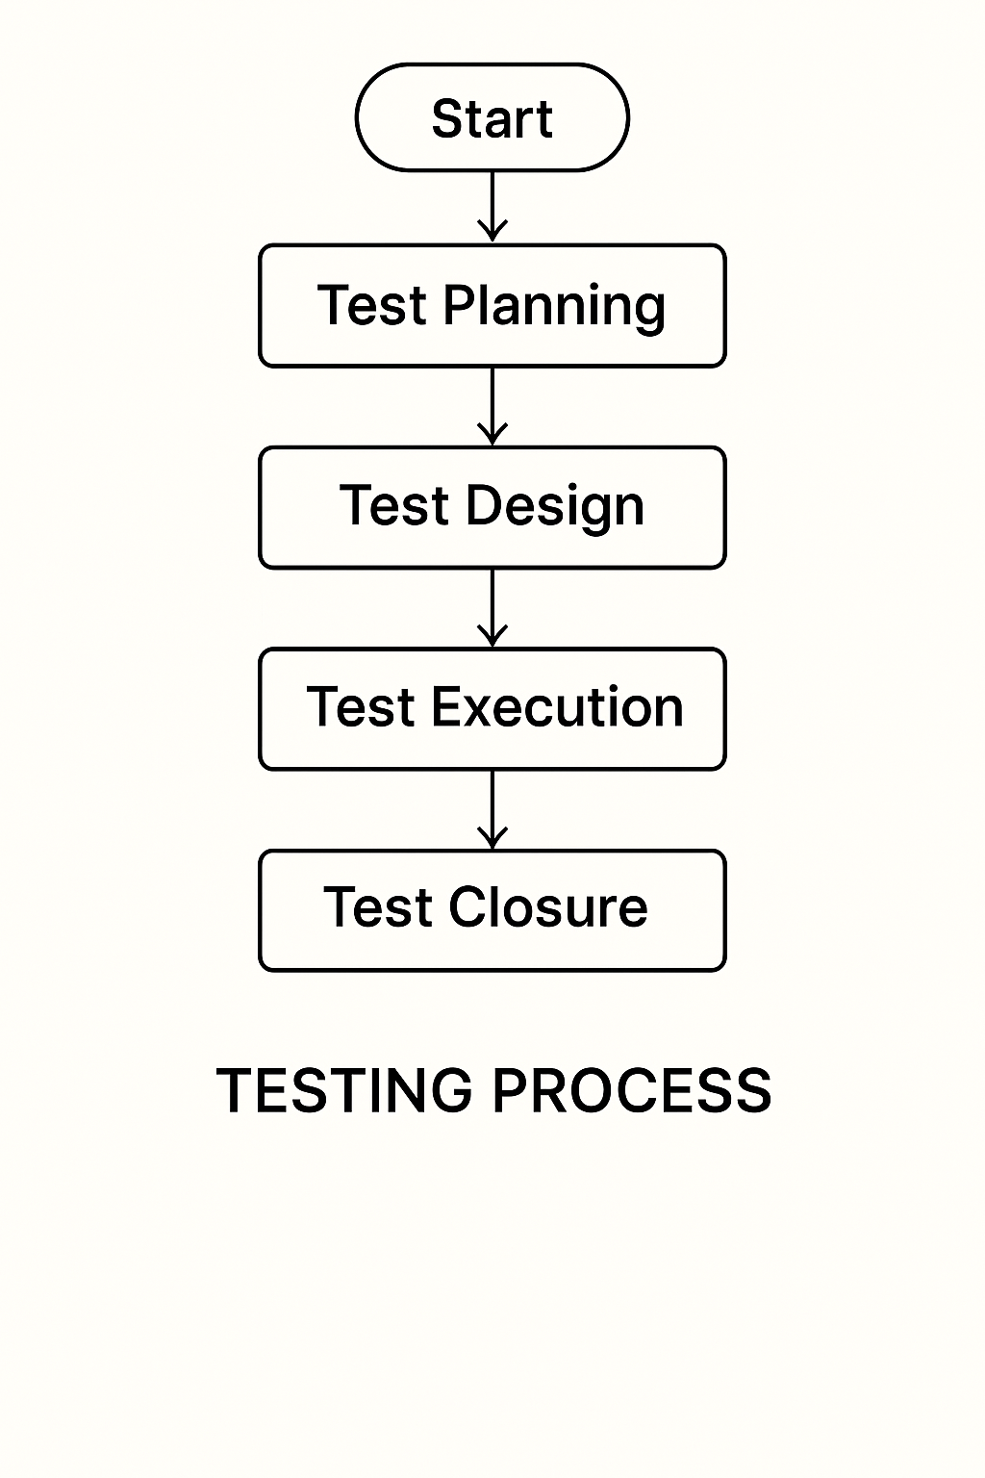

Figure for Testing Process

Test Plan:
The Testing Process: Developer tests the software process activity such as design, implementation and the requirement engineering. Because, design errors are very costly to repair when the system has been started to operate. Therefore, it is quite obvious to repair them at early stage of the system. So, analysis is the most important process of any project.

Requirements Tractability: As most interested portion is whether the system is meeting its requirements or not, for that testing should be planned so that all requirements are individually tested. Developer checked the output of certain combinations of input, which gives desirable results, or not. Strictly stick to our requirements specifications, give you the path to get desirable results from the system.
Tested Items
Our tested items are like:
- Data fetching from the database
- Data insertion, updating and deleting in the database
- Form access to login

Testing Schedule:
Developer has tested each procedure back to back so that errors and omissions can be found as earliest as possible. Once the system has been developed by fully developer tested it on other machines, which differs in configuration.
Testing Methods:
Software testing involves executing an implementation of the software which tests data and examining the outputs of the software and its operational behavior to check that it is performing as required.
Statistical Testing:
Statistical testing is used to test the program’s performance and reliability and to check how it works under operational conditions. Tests are designed to reflect the actual user inputs and their frequency. The stages involved in the static analysis for this system are follows:
Control Flow Analysis:
- Unreachable code
- Unconditional branches into loops
Data Use analysis:
- Variable used before initialization
- Variables declared but never used
- Variables assigned twice but never used between assignments
- Possible array bound violations
- Declared variables

Interface Analysis:
- Parameter type mismatches
- Parameter number mismatches
- Non-usage of the results of function
- Uncalled functions and procedures
Storage Management Faults:
- Data not stored in proper tables
- Data cannot be fetched from proper table
Defect Testing:
Defect testing is intended to find inconsistencies between a program and its specifications. These inconsistencies are usually due to the program faults or defects.
Loop Testing:
The Tester has tested some conditions in a code of application. So, they test the looping in source code of application for finding miss route or any error or wrong direction of flow in code.
Black-Box Testing:
In black box testing or functional testing, the developer is concerned about the output of the module and software, i.e. whether the software gives proper output as per the requirements or not. In another words, this testing aims to test a program behavior against specification without making any reference to the internal structure of the program or the algorithms used.
This can be done in the following way:
- Input Interface
- Processing
- Output Interface.
Whitebox Testing:
It is also called ‘GLASS BOX’ or ‘STRUCTURAL’ testing. Tester has access to system design.
- Simple Loops
- Nested Loops
- Concatenated Loops
- Unstructured Loops
- Continuous Loops
Advantages of White box testing:
- As the knowledge of internal coding structure is prerequisite, it becomes very easy to find out which type of input / data can help in testing the application effectively.
- The other advantage of white box testing is that it helps with optimizing the code.
- It helps in removing the extra lines of code, which can bring in hidden defects.

Structure Testing:
Developer has done his path testing to exercise every independent execution path through a component or program. If every independent path is executed, then all statements in the components must have been executed at least once. The structure of our program is also checked.
Integration Testing:
After our individual modules the Developer tested out Developer go to the integrated to create a complete system. This integration process involves building the system for problems that arise from component interactions. Developer has applied a top-down strategy to validate high-level components of a system before design and implementations have been completed.
Performance Testing:
Performance testing is designed to test the runtime performance of the system within the context of the system. These tests Developer performed as module level as developer as system level. Individual modules developers tested for required performance.
Condition Testing:
Condition testing is a test case design method that exercises the logical conditions contained in a program module. If the condition is incorrect, then as least one part of the condition is incorrect. It may include:
- Boolean variable error
- String index out of Bound error
- Null pointer Assignment
- Input Output Connection Exceptions
- Arithmetic expression error
- Parsing (conversion) errors
- Image unloaded errors

Interface Testing:
Interface testing is an integral part of integration testing. Therefore, the developer checked for the following.
- Interface misuse
- Interface misunderstanding
Developer examined the code to be tested and explicitly list each call to an external component. In the system, standards tests for various modules have been performed, which are follows.

Object Testing:
Object testing is to test objects as individual components, which are often larger than single function. Here the following activities have taken place.
- Testing the individual operations associated with object.
- Testing individual object classes.
- Testing cluster of objects.
- Testing object-oriented systems.
Now we will discuss how testing and debugging is done of this application. Our application can be divided into parts like:
- To make queries to database and retrieve information from it.
- Reduce some memory requirements for the database.
- Maintain database so that unauthorized access can not affect.
Limitations
- It can run only on windows servers. It is not compatible with LINUX servers.
- It is not cent percent safe from professional hackers.
- Only registered user can buy and sell their items using this website.
CONCLUSION
The Fit Kit application is a comprehensive, user-focused fitness and wellness platform that addresses the modern-day challenges of maintaining a healthy lifestyle. By integrating personalized workout plans, diet guidance, real-time tracking, and motivational tools, it empowers users to take full control of their fitness journeys.
With an intuitive interface, goal-oriented design, and continuous feedback loop, Fit Kit not only enhances physical fitness but also promotes mental well-being through features like meditation support, sleep tracking, and health reminders.
The system is technically feasible, economically viable, and operationally practical, making it a sustainable solution in the booming health-tech industry. By combining technology with expert guidance, Fit Kit transforms smartphones into personal fitness assistants, helping users stay healthy, motivated, and consistent.

FUTURE SCOPE OF THE PROJECT
The Fit Kit platform has strong potential for expansion and enhancement in the coming years. As user needs and health technologies evolve, the following developments can be explored to make the system more intelligent, interactive, and impactful:
1. Integration with Wearable Devices
- Sync with fitness bands, smartwatches (like Fitbit, Apple Watch, Mi Band) to automate step counting, heart rate, and sleep tracking.

2. AI-Powered Recommendations
- Use artificial intelligence and machine learning to:
  - Predict and recommend personalized workouts and diet changes.
  - Adjust plans based on user consistency and performance trends.
3. Live Trainer Sessions
- Offer live or recorded sessions with certified fitness trainers, yoga instructors, and nutritionists.
4. Community & Social Features
- Add features for fitness challenges, friend leaderboards, and community groups to encourage healthy competition and motivation.
5. Mental Health and Wellness Expansion
- Introduce guided meditation, stress management routines, journaling, and mental wellness assessments.
6. Health Analytics Dashboard
- Advanced data visualization and reports to track overall health trends over weeks or months.
- Integration with doctors or dietitians for remote health monitoring.
7. Multilingual and Voice Support
- Add support for regional languages and voice-based commands for accessibility and ease of use.
8. Corporate and School Wellness Programs
- Partner with institutions to offer Fit Kit as a corporate fitness tracker or student wellness tool.

BIBLIOGRAPHY
Reference Book:
- Head First JAVASCRIPT with MERN & MONGODB- By Lynn Beighley & Michael Morrison, The Complete Reference- JAVASCRIPT- with MERN (Dwight Merriman, Eliot Horowitz, and Kevin Ryan).
Reference websites:
- www.youtube.com
- www.w3schools.com
- www.javatpoints.edu

